Ant Café
Refillable Bait Stations
By Innovative Pest Control Products
P.O.Box 880216, Boca Raton, Florida 33488 Tel.561.483.4997
Contents : 48 Bait Stations, 48 Anchoring Tapes & 50 Locking Ties

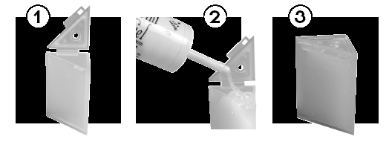

- Description:  - The "Ant Cafe" is a one piece bait station for crawling insects.  - The "Ant Cafe's" polypropylene construction allows it to be used indoors or outside.  - The " Ant Cafe" is adjustable, initially only one end is open, the 1/8" access is ideal for reducing liquid bait evaporation, while still allowing access to small sweet feeding ants.  - The size of the hole in the hinged end can be increased (by inserting the tip of a pen or pencil) to the precut 1/4" diameter  - The sealed end can also be adjusted in the same manner to allow either a 1/8" or 1/4" access  - The larger diameter holes are used when large ants or small roaches are the target pest and a granular or gel type bait is used  - The "Ant Cafe" can be securely sealed by passing a locking plastic tie through the molded eyelets  - The triangular shape permits placement close to walls, on window sills, and even kitchen counters  - The " Ant Cafe" can be secured in place inside or out with our locking tie and/ or tape anchor system | Hints for more effective use:  - Always store "Ant Cafe's" away from chemicals  - Always keep "Ant Cafe" in sealed zip lock storage container  - Keep "Ant Cafe" away from cigarette, cigar and pipe smoke  - Wash hands thoroughly before handling insect baits or bait stations, if you have been handling repellent pesticides or smoking  - Do not use non bait pesticides on or near "Ant Cafe" bait stations.  - Identify the target insect  - Select the bait formulation and active ingredients most appropriate to the target pest  - All insect pests require food, water and shelter. Place your "Ant Cafe" between two of these requirements and adjacent to observed activity  - Keep baits fresh, even our "Ant Cafe" won't keep baits fresh forever  - When reusing bait stations, flush thoroughly with water and dry before adding new bait  Good Luck and Thank You for using our Products  Sincerely,  Alan S. Bernard  Entomologist

